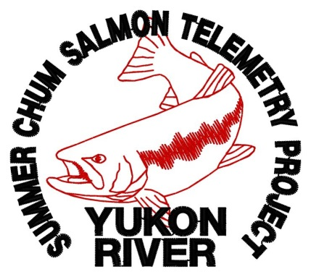

***Where do summer chum travel and spawn on the Yukon River? When do different stocks enter the river and how fast do they swim to their spawning locations?*** In order to answer these and other questions, ADF&G will begin a radio telemetry study for summer chum salmon in 2014.

***Summary***

* ADF&G and local fisherman will use modified gillnets to catch and tag 1200 summer chum salmon near Russian Mission with white spaghetti tags and radio tags
* Tagged salmon will be tracked upriver by tracking stations and aerial surveys
* Results from this study are needed for summer chum management

***Goals***

* Estimate stock specific
  + Run timing
  + Migration rates
  + Movement patterns
  + Distribution
* Identify important spawning tributaries
* Get a picture of how much each stock contributes

to the overall summer chum population

* Estimate drainagewide escapement
* Identify the relationship between the Anvik River sonar and the sonar near Pilot Station

**We Need Your Help This Summer!**

Even tagged fish that are caught by **YOU** can provide valuable info about a salmon stock. If you catch a tagged chum salmon this year, please keep the tag and send it to ADF&G with catch information (see back of page).

Anyone who returns a tag will receive a custom **chum salmon project hat** and will be entered into a **cash prize lottery** and have a chance to win up to **$500**!

**For more information please contact**

**Sean Larson**

**Fishery Biologist, ADF&G**

**(907) 267-2385,** [**sean.larson@alaska.gov**](mailto:sean.larson@alaska.gov)